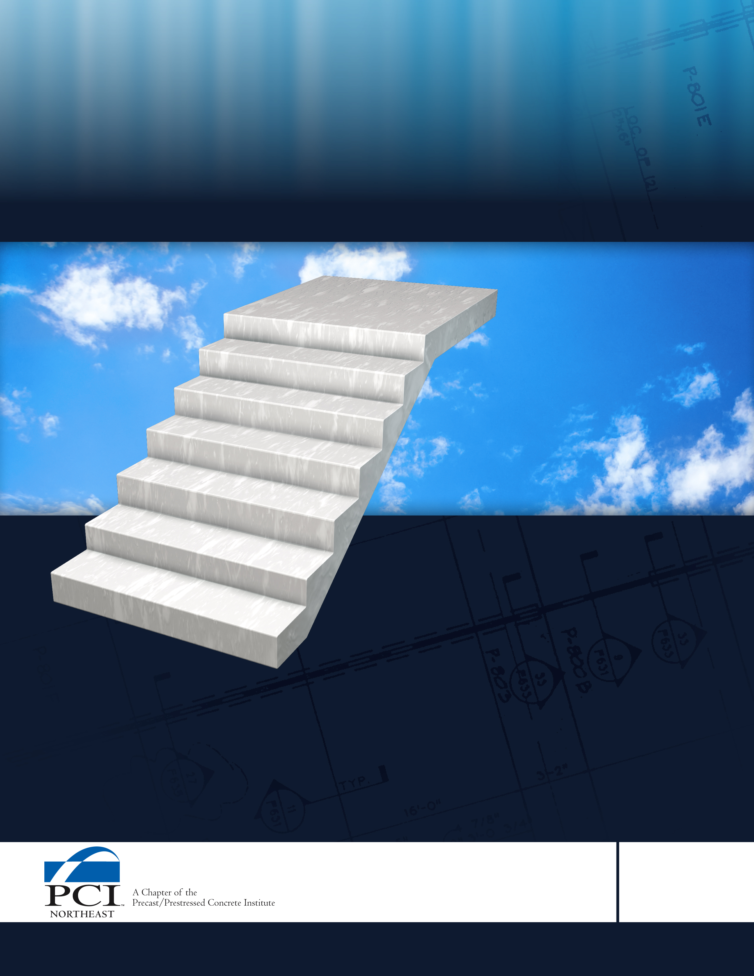

Precast Concrete Stairs
Specifications
Section 034123
DATE ISSUED
March 22, 2011




SPECIFICATIONS FOR PRECAST CONCRETE STAIRS

SECTION 034123

1. GENERAL

1.01 Description
A. Work Included: These specifications cover manufacture, transportation and erection of precast concrete stairs and landings.
- Related Sections:
- 03300 – Cast-in-Place Concrete: Site Cast Precast
- 03400 – Prestressed Hollowcore Plank
- Drawings and general provisions of the Contract, including General and Supplementary Conditions and Division 1 Specification Sections, apply to this section.

1.02 Quality Assurance
- Manufacturer Qualifications: Precast Prestressed Concrete Institute (PCI) Plant Certification Program and shall be certified in category C1.

- Erector Qualifications: Precast Prestressed Concrete Institute Qualified Erector and regularly engaged for at least 5 years in the erection of precast structural concrete similar to the requirements of this project. Retain a registered structural engineer to certify that erection is in accordance with design requirements.

- Welder Qualifications: In accordance with AWS D1.1.

- Codes and Standards: Comply with provision of following codes, specifications and standards, except as otherwise indicated.
- ACI 301 “Specifications for Structural Concrete”.
- ACI 318 “Building Code Requirements for Structural Concrete”.
- Concrete Reinforcing Steel Institute, “Manual of Standard Practice”.
- Precast Prestressed Concrete Institute MNL 116, Manual for Quality Control for Plants and Production of Precast Concrete Products”.
- Precast Prestressed Concrete Institute MNL 135, “Tolerance Manual for Precast and Pre-stressed Concrete Construction”.
- Precast Prestressed Concrete Institute MNL 120, “PCI Design Handbook”.
- American Welding Society, AWS D1.1 “Structural Welding Code-Steel”, D1.4 “Structural Welding Code – Reinforcing Steel”, D1.6 “Structural Welding Code - Stainless Steel”, C5.4, “Recommended Practices for Stud Welding”.

- Fabricator Qualifications: Fabricator must be certified producer member of the Precast/Prestressed Concrete Institute (PCI) and participate in its Plant Certification Program with a C1 classification.

- Performance Requirements:
1. Delegated Design: Design precast concrete stairs, including comprehensive engineering analysis by a qualified professional engineer, using performance requirements and design criteria indicated.
2. Structural Performance: Provide precast structural concrete units and connections capable of withstanding the following design loads within limits and under conditions indicated:
a. Stairs shall be designed to support the full dead load plus 100 psf live load.
b. short term and long term deflection shall be no greater than Table 9.5 (b) of
ACI-318.

1.03 Submittals and Design

- Shop Drawings:
- Erection drawings shall show dimensions for proper fabrication; reinforcing steel sizes, grades and locations; inserts accessories and handling methods; calculations for reinforcing; details, sections, jointing, anchoring, and all other necessary information.

- Tests and Reports:
- Perform all concrete testing in accordance with PCI MNL-116 requirements.

2. PRODUCTS

2.01 Materials

- Portland cement:
- ASTM C 150, Type I or III

- Reinforcing Bars: ASTM A 615/A 615M, Grade 60, deformed.

- Plain-Steel Welded Wire Reinforcement: ASTM A 185 or A497 fabricated from plain steel wire into flat sheets having a minimum yield strength of 70,000psi.

- Plates and Angles: Cast-in loose plates and angles shall conform to ASTM 36.

- Water: Potable, clean and free from oils, acids, salts or other injurious substances.

- Admixtures:
- Air entrainment agents shall conform to ASTM C 260.
- Precast elements exposed to weather or vulnerable to deicers shall have 6% + 1.5% of air entrainment.
- Water reducing agent shall conform to ASTM C 494, Type A.
- High range water reducing agent shall conform to ASTM C494 Type A.

G. Normal-Weight Aggregates:
- Fine Aggregates: ASTM C 33, washed natural sand
- Course Aggregates: Crushed stone conforming to ASTM C 33. Aggregate shall be graded crushed stone with a resulting weight of concrete up to 155 lbs./cu. ft.

H. Grout:
- Cement shall be gray Portland cement, free from soluble salts and complying with ASTM C 150, Type I or Type III High Early Strength, one brand throughout work. Strength shall be 4,000 psi in 28 days.

2.02 Concrete Mixes

A. 28-day compressive strength: Minimum of 5,000 psi
B. Use of calcium chloride or admixtures containing chlorides is not permitted.

2.03 Fabrication

- Casting shall be done in rigidly constructed forms designed to produce dimensionally correct members with uniform surfaces per shop drawings.

- At time of casting, manufacturer shall incorporate all accessories, reinforcing steel and handling devices required for proper installation and handling of units.

- Provide finished units, which are straight, true to size and shape, and within specified casting tolerances.

- Make exposed edges sharp, straight, and square. Make flat surfaces into a true plane.

- Place and secure in the forms all anchors, clips, stud bolts, inserts, lifting devices, shear ties, and other devices required for handling and installing the precast units and for attachment of subsequent items indicated and specified.

- Curing:
- Form curing by moisture retention without supplemental heat until concrete reaches adequate strength for removal of product from forms, a minimum of 2,500 psi.
- Precast units shall be cured to the required 28 day strength prior to shipment.

- Casting tolerances: Maintain casting, bowing, warping and dimension tolerances within PCI MNL-116 and PCI MNL-135.

2.04 Product Delivery, Storage, & Handling

- Delivery and Handling:
- Carefully transport and handle precast concrete stairs so as to prevent soiling or damage. Store clear of ground in manner to prevent cracking, distortion, warping and to protect from damage and dirt. Soiling or staining of precast units may be cause for rejection of units. Lift and support units only at designated lifting or supporting points as shown on approved shop drawings.

- Delegated-Design Submittal:
  - For precast concrete stairs indicated to comply with performance requirements and design criteria, including analysis data signed and sealed by the qualified professional engineer responsible for their preparation.

C. Examination:
    - Examine supporting structural frame or foundation and conditions for compliance with requirements for installation tolerances, true and level bearing surfaces, and other conditions affecting performance of the Work.
    - Proceed with installation only after unsatisfactory conditions have been corrected.
    - Do not install precast concrete units until supporting, building structural framing has attained minimum allowable design compressive strength or until supporting steel or other structure is complete.

3. EXECUTION

3.01 Erection

- Work to be performed by a PCI Qualified Erector. Install in accordance with shop drawings and manufacturer’s recommended installation procedures.

- Handling and Erection:
- Temporarily stabilize all precast work until permanent connections and/or adjoining cast-in-place concrete work or masonry has been completed and the framework is stable.

3.02 Grouting

A. Grouting:
- After precast units have been placed and secured, grout open spaces at connections and joints between platforms and stairs, and between platforms and floor plank.
- Place grout in a manner to finish smooth, plumb, and level with adjacent concrete surfaces.

3.03 Welding

A. Welding shall be continuous with Low-Hydrogen rods per AWS A5.1 or A5.5

3.04 Patching

A. Patch precast units if strength and appearance has not been impaired. Manufacturer of precast units shall point up all chopped areas. Pointed up areas shall have minimum variation in texture and color. Amount of variation shall be acceptable to the Architect.

3.05 Cleaning
- Remove rubbish and debris resulting from precast concrete stair work from premises upon completion.

END OF SECTION 034123

